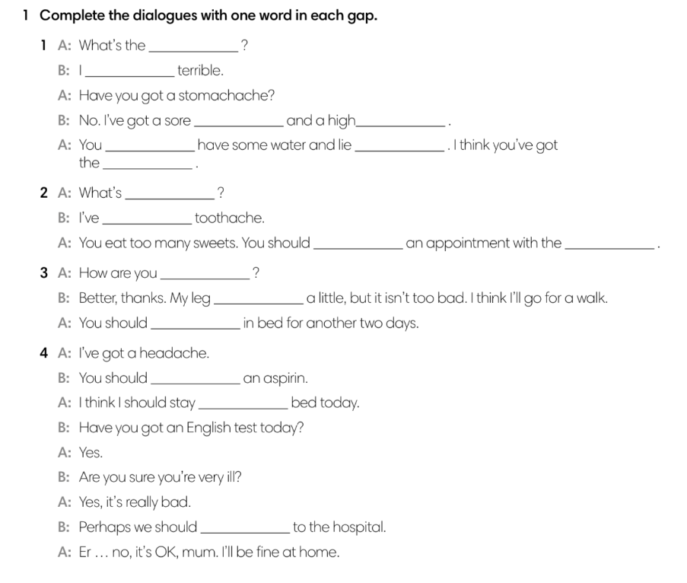

2. **Write a similar dialogue.**