Reading is Not a Waste of Time
(webinar)

Quotes about reading
“Reading is to the mind what exercise is to the body.“ (Joseph Addison)
“There is no friend as loyal as a book.” (Ernest Hemingway)
“Books are a uniquely portable magic.” (Stephen King)
“Reading should not be presented to children as a duty. It should be offered as a gift. (Kate DiCamillo)
“You cannot open a book without learning something.”(Confucius)
“All I have learned, I have learned from books.” (Abraham Lincoln)
Reading is a superpower.
My workout is reading in bed until my arms hurt.
I love reading because I don´t have to wait for the commercials to be over to find out what happens.

Ideas to encourage students to read
Being a reading model.
Creating reading wall (graffiti wall, reading card, emoji reads).
Using audio CDs, audiobooks.
Using alternative reading materials (cookery books, comics, magazines, newspaper).

Reading comprehension strategies
predicting, questioning, clarifying, visualising, connecting, evaluating

Activities
1/Fortune teller (cootie catcher) – for quick review of any book
https://www.youtube.com/watch?v=nreDjXoCCpI how to use fortune teller
https://www.youtube.com/watch?v=PAZKv_PVcn0 how to make fortune teller
http://classroomgamenook.blogspot.com/2016/05/using-cootie-catchers-for-reading.html

2/Reading comprehension cubes – talking about book
https://www.youtube.com/watch?v=qqk7SmjFQCA
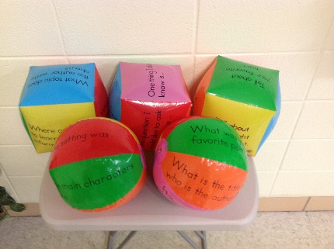
-to make it a fun game make a competitin of how many questions each person can answer in one minute
3/Retelling gloves, sticks, rope
https://www.youtube.com/watch?v=TZ_phFEUghA
4/Wanted poster- students describe physical appearance and character trait of the hero
https://www.education.com/activity/article/wanted-poster/
5/Lifetime tale in pictures – students draw the main character as a child, a middle aged person and an older pearson, below each picture they write what the person (hero) might be doing at that point of his/her life and explain why
6/Yellow brick road – children hop from one brick to the next retelling the story.
https://thefirstgradeparade.org/follow-yellow-brick-road-retelling/
7/Making connection- text to self, text to text and text to the world
http://www.readwritethink.org/professional-development/strategy-guides/making-connections-30659.html
https://www.robeson.k12.nc.us/cms/lib/NC01000307/Centricity/Domain/3916/Making%20Connections.pdf
8/ Prediction – based on title, book cover, pictures from the book, graphs from the book, character behaviour of the hero ( Three Little Pigs and the Wolf), parts of the article, key word (try to find out what the story is about) https://www.youtube.com/watch?v=8FllWtxvoec
What do you think will happen in the book?
Why do you think that....ask students for clarifying
9/Srew up- skimming- find a text, roll/srew i tup into a ball, students can´t unroll the ball,students read what they can to understand the gist
https://www.youtube.com/watch?v=8FllWtxvoec
10/Grass strip – scanning – find a text, create a list of questions about it, cut the list into grass skirt, hang on the wall, every group has its own grass skirt, one of the student runs to the wall, grab one question and runs back to find out the answer, then another student does the sam activity till they find out the answer to all questions, the winner is the group which founds all answer first
https://www.youtube.com/watch?v=8FllWtxvoec
Extra activities
1/Questioning the author
https://www.readingrockets.org/strategies/question_the_author
2/Write a film version of the story
3/ Create video book commercials
4/Write book review
5/ Story maps https://www.education.com/slideshow/printable-story-maps/

